VARUN BHARGAVA – 241010282
DATA STRUCTURES TASK-8

Task 01: Josephus Problem:
(https://github.com/varunnnb/dsa-sem3-iiitnr/blob/main/lab8/lab8-1.c)
Write a program that simulates the Josephus Problem, where n players stand in a
circle and every kth player are eliminated until only one player remains. The
program should determine and print the position of the winner (survivor).
Example:
Input: n = 7, k = 3
Output: The winner is player 4

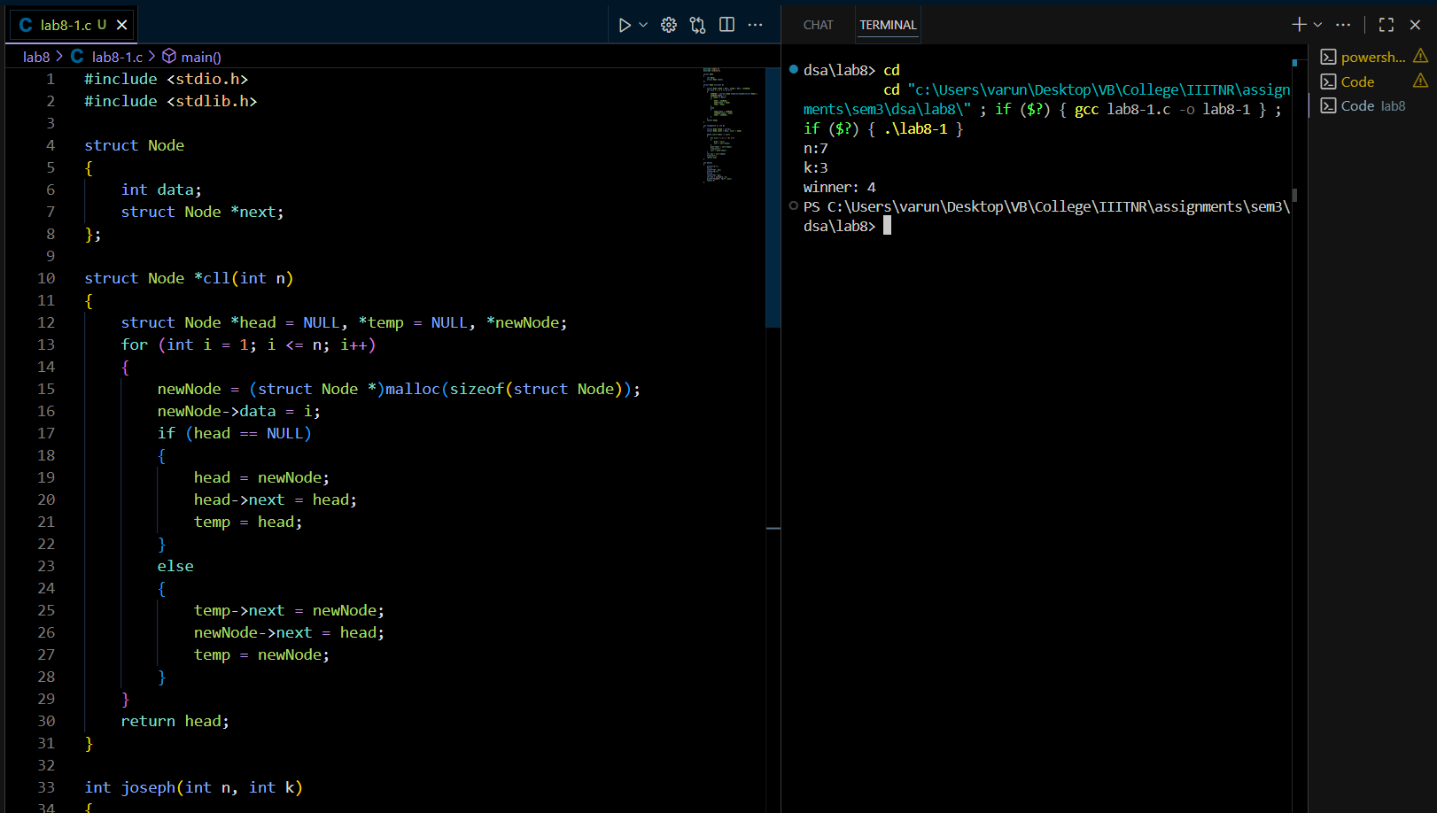
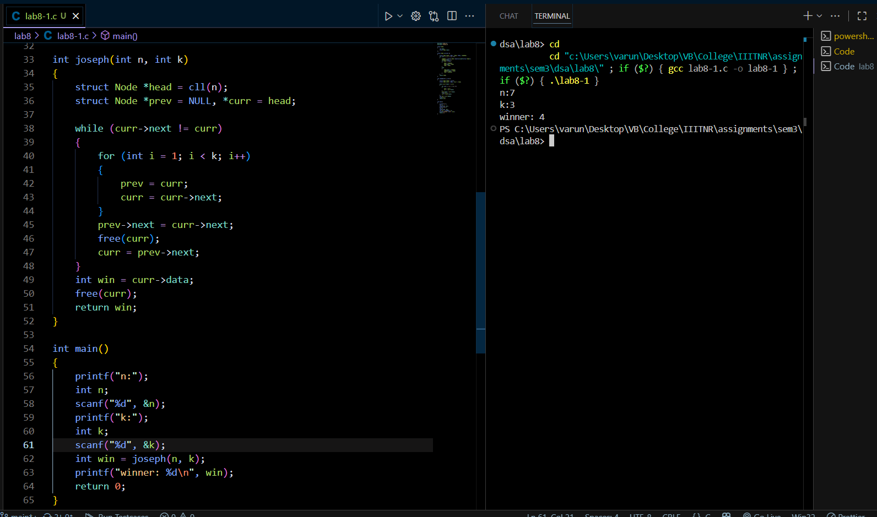
Task 02: Single Linked List – Longest Ascending Sequence:
( https://github.com/varunnnb/dsa-sem3-iiitnr/blob/main/lab8/lab8-2.c)
Write a program using a single linked list that takes input from the user and prints
the longest sequence of ascending order integers in it along with the length.
Example:
Input: 20, 2, 5, 17, 77, 7, 5, 3
Output: Longest ascending sequence: 2 5 17 77
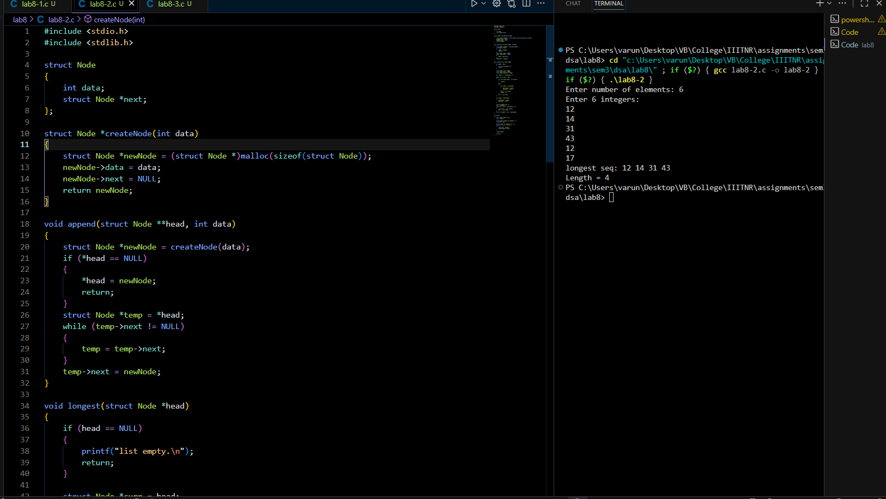
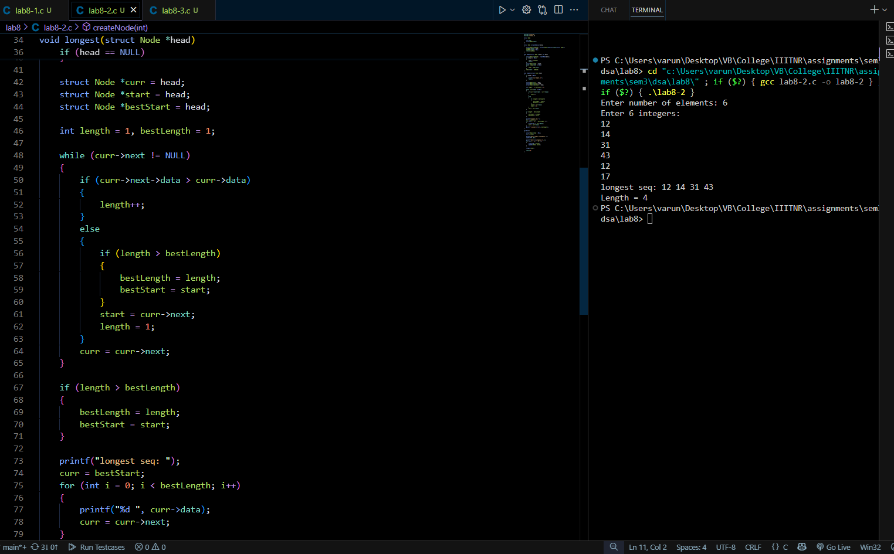
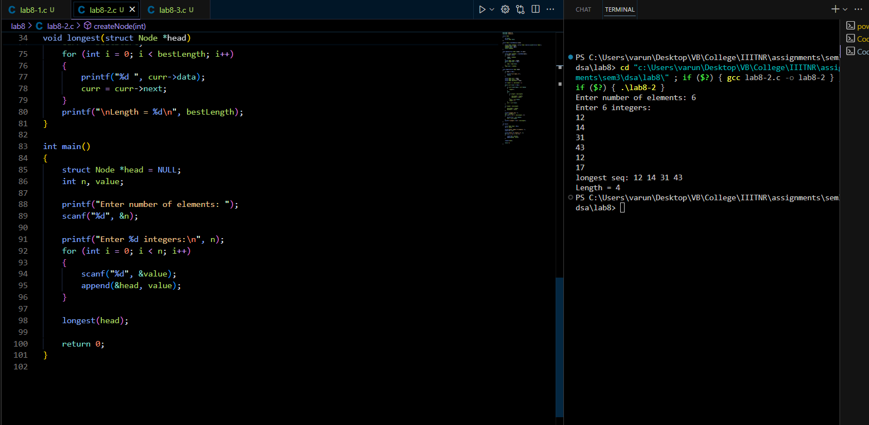

Task 03: Anagram Check:
( https://github.com/varunnnb/dsa-sem3-iiitnr/blob/main/lab8/lab8-3.c )
Check whether two input strings are anagrams or not
Example:
Input: listen, silent
Output: Strings are Anagrams

